Power & Propaganda

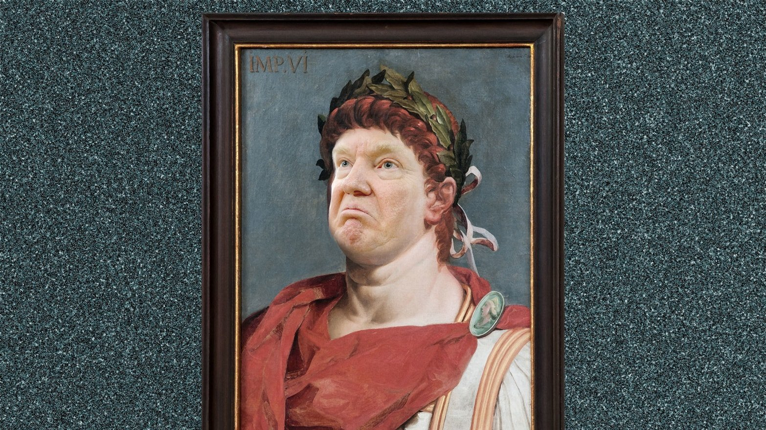
Photo Illustration by Emil Lend of The Daily Beast
This interactive, two-hour workshop will introduce students to examples of ancient and modern political power and propaganda, and ask what can be gained by comparing the two. No knowledge of ancient history is required or assumed. A healthy appreciation of politics is welcome.
How might we define ‘political power’ or ‘propaganda’, what forms do they take, and what relevance do ancient examples have in the modern world? This workshop sets out to explore what can be gained (or lost) by evoking the politics of ancient Rome in contemporary debate, and why Classics continues to be relevant to politics in the 21st century.
During the workshop, students will:
- Discover the history of ancient Rome;
- Encounter ancient sources, from coins and altars to statues and literary sources;
- Discuss modern representations of ancient Roman on film;
- Critique contemporary propaganda, including the Brexit Bus and Donald Trump’s Tweets;
- Undertake group work on 21st century journalism that draws direct comparisons between modern political figures and the emperors of Rome;
- Present their views on the politics of antiquity and its relevance to modernity.
If you are interested in hosting this workshop, or a shorter variant, at your school, please email the Bristol Classics Hub (classics-hub@bristol.ac.uk), along with the workshop organiser, Dr Richard Cole, richard.cole@bristol.ac.uk).

